

YEAR: 9
SUBJECT: SCIENCE

TEST: Matter
QUESTIONS: Part A: Multiple Choice Questions (10 marks)
Part B: Short Answer Questions (38 marks)
Part C: Extended Response (6 marks)

TOTAL MARKS: 54 marks

DO NOT WRITE ON OR MARK THIS PAPER

SECTION ONE: Multiple Choice Questions (1 mark each)
Answer this section on the separate multiple – choice answer sheet

- Which of the following statements about atoms is true?
- Neutrons and protons are found in the nucleus with the electrons
- The number of neutrons found in the nucleus of an atom is always the same
- Protons circle the nucleus all the time
- An atom is mostly empty space

- The nucleus of an atom is made up of
- electrons and protons
- protons and neutrons
- neutrons and electrons
- neutrons

- An ion is best defined as: An atom which has

- lost electrons
- gained electrons
- gained or lost electrons
- gained neutrons

- The atomic symbol for a gold atom is 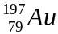. Clarify what this tells you about the gold atom.

- It contains 118 protons.
- It contains a total of 197 protons, neutrons and electrons.
- It contains 118 neutrons.
- It contains 197 electrons.

- To learn more about electrons, Joseph John Thomson passed an electron beam through a pair of electrodes. He found that the electron beam shifted towards the positive electrode. Given that like charges repel each other and opposite charges attract, deduce what Thomson could conclude about the charge of the electrons.
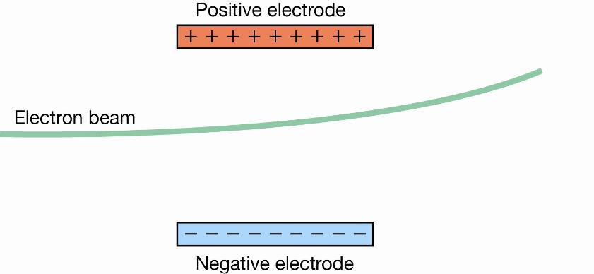

  - Electrons are charged, but might be positively or negatively charged.
  - Electrons are negatively charged.
  - Electrons are positively charged.
  - Nothing can be concluded about the charge of the electrons.

6. Determine which of the following atoms are isotopes of the same element.
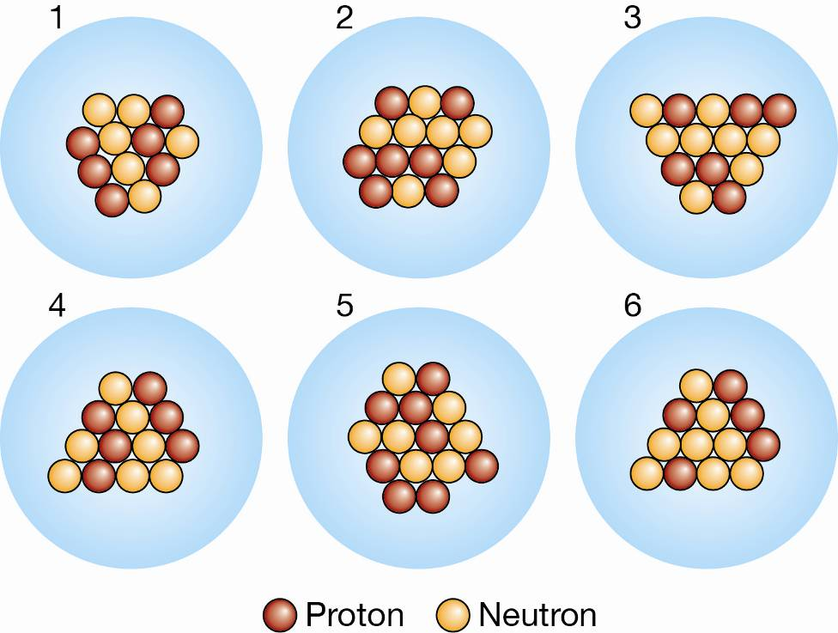
a. 1 and 4
b. 1, 3 and 4
- 2 and 5
- 3 and 6

7. A radionuclide is:
- a radioactive isotope.
- a charged atom
- an element that emits beta radiation.
- an atom with the same number of protons but a different number of neutrons.

- The mass number of an atom is the number of
- neutrons in its nucleus.
- electrons in the nucleus.
- protons in the nucleus.
- protons plus neutrons in the nucleus.

- Which of the following will cause an atom to become a negative ion?
- gain electrons.
- lose protons.
- gain neutrons.
- lose neutrons.

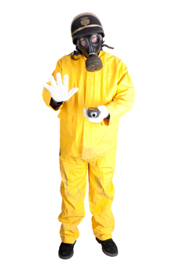
- Scientists use the process of decay in radioactive isotopes called to determine the of organisms.

- aging; carbon
- radioactive aging; carbon
- dating; age
- carbon dating; age


SEMESTER ONE 2020
Chemistry Test:
ANSWER BOOKLET
NAME:
FORM: DATE:

Multiple Choice Short Answer Extended Response Total

/10

/38

/54

/6

SECTION ONE: Multiple choice answers
Cross (X) through the correct answer.

1 | a | b | c | d
2 | a | b | c | d
3 | a | b | c | d
4 | a | b | c | d
5 | a | b | c | d
6 | a | b | c | d
7 | a | b | c | d
8 | a | b | c | d
9 | a | b | c | d
10 | a | b | c | d

SECTION TWO: Short Answer (38 marks)
Answer the questions in the spaces provided.

Question 11
- List which particles in a neutral atom have: (2 marks)
i. equal but opposite charges protons and electrons (1 mark)
ii. approximately the same mass. protons and neutrons (1 mark)
- Define the following terms : (5 marks)
Atomic number: The number of protons (1)
Sub-atomic particles: the parts that make up an atom, (0.5) PEN (0.5)
Electron configuration: the number of electrons (0.5) in each of the shells (0.5)
Isotope: the different forms of an element (0.5) that have different numbers of neutrons (0.5)
Natural radioactivity: the energy (0.5) given out by a substance to become more stable (0.5)
- Draw a diagram of the Lithium atom, ₃Li ⁷ labelling the 2 main parts of an atom, show the correct number of the protons, electrons and neutrons, and indicate their charge. (5 marks)
Nucleus, Electron cloud – Correctly labelled 0.5 each – 1 mark total
Protons – 3- in nucleus 0.5, positive charge (0.5)- 1 mark total
Electrons -3 (0.5) – 2 in K shell, 1 in L shell (1) or just 0.5 if in electron cloud , negative charge(0.5) – 2 marks
Neutrons- 4- in nucleus (0.5) , neutral or no charge (0.5) – 1 mark total

Question 12

Identify the number of protons, neutrons and electrons in the atom of potassium: (3 marks)
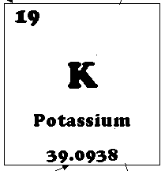

- protons: 19
- neutrons: 20
- electrons: 19

Question 13
- For the electron configuration of the atom given below, construct an electron diagram and write the name of the element you have drawn. Use this atom to answer all parts of this question. (2 marks)
(Electron diagram: 1 mark Name of the element: 1mark)
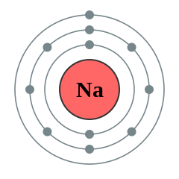
Electron Configuration: 2, 8, 1
Element: Sodium

- Identify (i) Number of electrons in the valence shell: 1 (1mark)
(ii) Type of ion formed: cation (1mark)
- Draw the complete electron shell diagram for the ion that is formed by this atom. (3 marks)
1 mark if have electron shells correct with additional electron drawn in ie 2,8
1 mark for drawing in the square brackets
1 mark for identify charge outside of bracket as +1

- State the electron configuration of the ion. ( 1 marks) 2,8
- Demonstrate how the charge on the ion is calculated ie provide the sum. ( 2 marks)
P= 11=+11 (0.5)
E=10=-10 (0.5)
Total=-1 (0.5)
(0.5) set up like a sum showing all working out indicating numbers and charges

Question 14
Carbon has different isotopes, as shown in the diagram below.
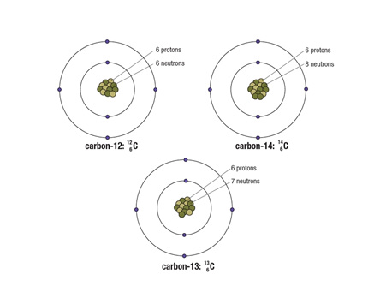
Describe the similarities and differences between these shown. (3 marks)

Similarities Any 2 of the following (1 mark each)
- All of the atoms of carbon have the same atomic number = 6 = number of protons
- All isotopes have same number of electrons
- All of isotopes have same number of shells or orbits
Differences (1mark)
- Each of the atoms is a different isotope of carbon, which means that they have different numbers of neutrons in the nucleus
Question 15
The atoms below are written using the letters V to Z instead of their correct chemical symbols.
  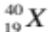 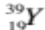 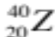 (4 marks)
- Which two atoms have the same number of neutrons?
Y (0.5) and Z (0.5)
- Which atom has the smallest mass number?
W
- Which two atoms belong to the same element?
X (0.5)and (0.5)Y
- Which atom has the electron configuration 2, 8?
W
Question 16
This paragraph has some missing words. Their positions are numbered. (6 marks)
Ernest (1) proposed a new model for the atom where there is a small positively-charged (2) surrounded by (3) -charged electrons. Later on scientists discovered that there were two types of particles inside the nucleus—positively-charged (4) and neutrons, with no (5) . The number of protons is always the same as the number of (6) .

Which word goes in which position? Choose the correct word from the jumbled list below by writing each one in the correct numbered position:
charge electrons negatively nucleus protons Rutherford
(1) Rutherford
(2) nucleus
(3) negatively
(4) protons
(5) charge
(6) electrons

SECTION THREE: Extended Response (6 marks)
- Some isotopes of the elements are unstable. This means they may undergo decay or change into another isotope and emit certain radiations.
- What do you mean by the term half-life of a radioactive material? (1 mark)
- List three types of radiation in order from least penetrating to most penetrating.(2 marks)
- Compare the (similarities and differences) properties of those radiations. You need to show at least two properties for each radiations. (3 marks)

- The half-life of a radioactive material is the time taken for half of the radioactive nuclei in a sample to decay. (1 mark)
- Alpha, Beta and Gamma radiation 1- mark any order plus bonus 1 mark if listed in correct order
- Alpha (α) particles (Any two properties ½ mark each. Total: 1 mark)
- An alpha particle is identical to the nucleus of a helium nucleus. It contains two protons and two neutrons.
- Alpha particles are large, heavy and slow (10% of speed of light).
- They can only travel a few centimetres in air and is easily stopped by a thin sheet of paper or dead skin

Beta (β) particles (Any two properties ½ mark each. Total: 1mark)
- Beta particles are identical to electrons and therefore are very small and have a negative charge.
- The beta particles that make up beta radiation are small and fast (90% of speed of light). This means that beta radiation penetrates the skin more deeply than alpha radiation.
- Beta radiation can be blocked by a thin plate of aluminium.

Gamma (γ) radiation (Any two properties ½ mark each. Total: 1 mark)
- Gamma radiation can travel through skin, bone and aluminium, making it extremely dangerous to humans
- A thick layer of concrete or lead can block the radiation
- Gamma radiation is made up of electromagnetic waves rather than particles.
- Gamma rays do not have any mass or charge and travel at the speed of light.

